**Project Design Phase-II**

**Technology Stack (Architecture & Stack)**

|  |  |
| --- | --- |
| Date | 03October 2022 |
| Team ID | PNT2022TMID16374 |
| Project Name | A Gesture-based Tool for Sterile Browsing of Radiology Image |
| Maximum Marks | 4 Marks |

**Technical Architecture:**

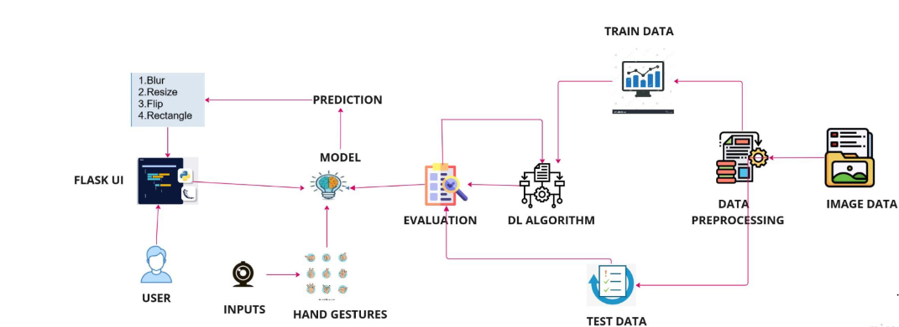

**Table-1 : Components & Technologies:**

Guidelines:

1. Include all the processe (As an application logic / Technology Block)
2. Provide infrastructural demarcation (Local / Cloud)
3. Indicate external interfaces (third party API’s etc.)
4. Indicate Data Storage components / services
5. Indicate interface to machine learning models (if applicable)

|  |  |  |  |
| --- | --- | --- | --- |
| **S.No** | **Component** | **Description** | **Technology** |
|  | User Interface | Web UI | HTML, CSS, JavaScript |
|  | Application Logic-1  Image Pre-processing | Input image is pre-processed with the help of library files available in Python like opencv, numpy, scikit-image | Python, OpenCV, Numpy, Scikit-image |
|  | Application Logic-2  Building model | Building CNN model to interpret and recognize the gesture with the help of library files available in Python like Keras, Tensorflow | Python, Keras, Tensorflow |
|  | Application Logic-3  Creation of app | App is built to obtain gesture as input and to provide corresponding output for that manipulated images | HTML,CSS, JavaScript,Python,Flask |
|  | Dataset | Hand gesture dataset with various position for the same hand gesture | From IBM. |
|  | Cloud Database | User input image is stored in the cloud | IBM Cloudant DB |
|  | File Storage | File storage contains dataset and source code | Local File system |
|  | Machine Learning Model | CNN model is used to interpret and recognize the pre-processed image either by image capturing or by video segmenting | CNN Model by Python, Keras, Tensorflow |

**Table-2: Application Characteristics:**

| **S.No** | **Characteristics** | **Description** | **Technology** |
| --- | --- | --- | --- |
|  | Open-Source Frameworks | Open-source framework software is used for application development, model training and version control | **Editors:** Visual Studio Code, Atom  **Languages and Libraries:** Python, Tensorflow, Keras, JavaScript, OpenCV, HTML, CSS, Numpy, Scikit-image  **Framework:** Flask  **Version control:** GitHub, GitLens |
|  | Robustness | Hand gestures can be captured at different angles and under varied conditions | Scikit-image, OpenCV |
|  | Scalability | The system limits the number of user requests to one per second, serve each request on a separate thread | Python |
|  | Availability | The application is deployed on a high-performance, reliable server | IBM Cloud |
|  | Performance | Light-weight SOTA deep learning model with low inference time | Tensorflow, Keras |

**References:**

**Flask Folder:**

[**https://drive.google.com/drive/folders/1a6VhgaR2KZcKGkynQw4bOISLd3IT917m?usp=sharing**](https://drive.google.com/drive/folders/1a6VhgaR2KZcKGkynQw4bOISLd3IT917m?usp=sharing)

**Dataset:**

[**https://drive.google.com/drive/folders/1FdfEE_22aEwAQ6UCtnPvUhznpmM4z09v?usp=sharing**](https://drive.google.com/drive/folders/1FdfEE_22aEwAQ6UCtnPvUhznpmM4z09v?usp=sharing)